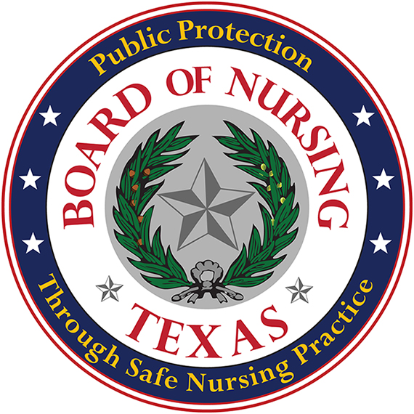
TEXAS BOARD OF NURSING (BON)
333 Guadalupe, Suite 3-460
Austin, Texas 78701-3942
Telephone: (512) 305-7400 Fax: (512) 305-8101
Web Address: www.bon.texas.gov

Application for Approval of a Pre-licensure Nursing Education Program Outside Texas’ Jurisdiction to Conduct Clinical Learning Experiences in Texas
Name of School/Governing Entity:

Physical Address of School/Governing Entity:

Web Site Address:
Telephone Number:
Type of Nursing Education Program (LVN/LPN, Diploma, ADN, Baccalaureate):

Physical Address of Nursing Education Program, if different than above:

Telephone Number, if different than above:
Name, Title, and Credentials of Contact Person:
Telephone Number of Contact Person:
Email Address of Contact Person:
List of all signed affiliation agreements in Texas to conduct pre-licensure nursing clinical learning experiences (include city):

Nursing Education Program Approval Fee as indicated in Rule 223.1 (25) must be submitted with the Application of a Nursing Education Program Outside Texas’ Jurisdiction to Conduct Clinical Learning Experiences in Texas.
**************************************************************************************************************
BON USE ONLY

Date Received: __________ Payment Number: __________ Amount: __________

Deposit Number: ________________________ Date of Deposit: ________________

